Wiring and Testing the BME280

The BME280 is and digital sensor that measures temperature, pressure, and humidity. It will also automatically use the pressure reading to measure and report the altitude.
Wiring
Start by wiring the device over the SPI bus as shown in the diagram below. Do not disconnect the device the SD card from the previous activity.

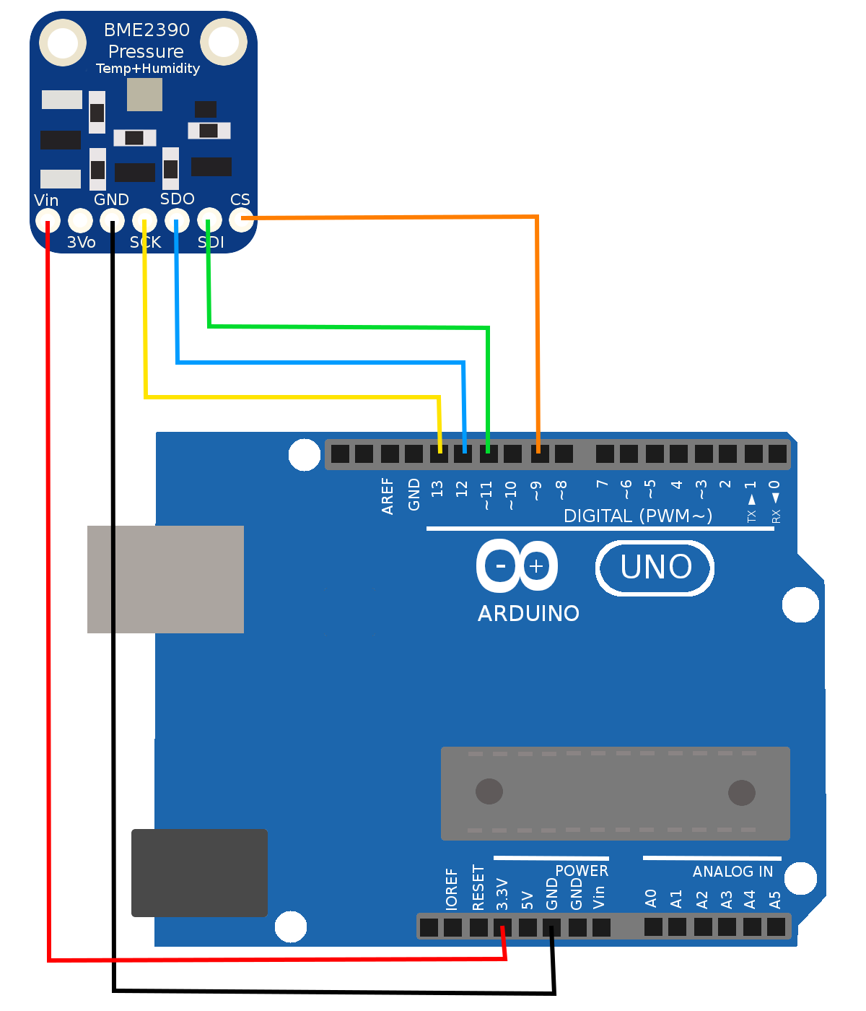
 | Device Pin | Arduino Pin | Name
 | Vin | 3.3V | Power
 | GND | GND | Ground
 | SCK | 13 | Serial Clock Line
 | SDO | 12 | Serial Data Out
 | SDI | 11 | Serial Data In
 | CS | 9 | Chip Select

Testing
Now open the included sketch 'TempSensor.ino' from the src folder. Upload this code to the Arduino and open the serial monitor. You should see a starting message followed by data from the BME280 being printed over the serial monitor. This includes temperature in degrees C, pressure in pascals, altitude in meters and percent humidity.
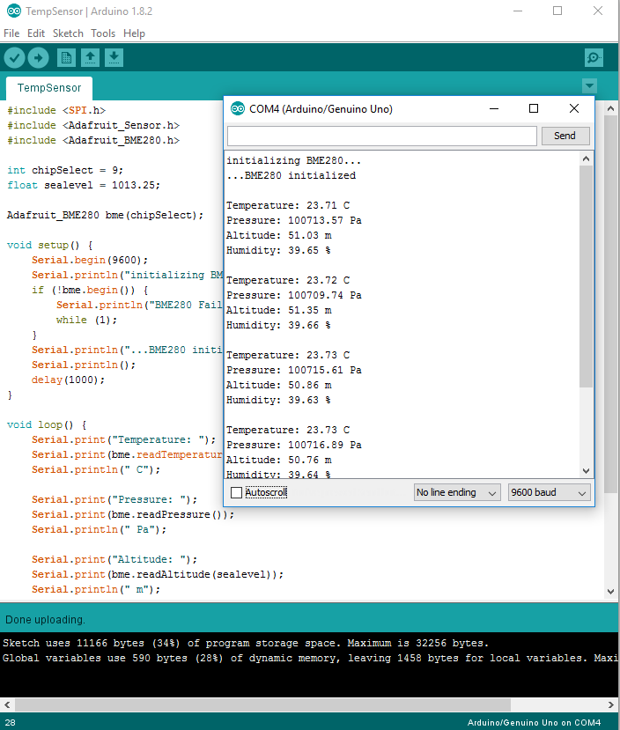

Code Walkthrough

#include <SPI.h>
#include <Adafruit_Sensor.h>
#include <Adafruit_BME280.h>

In the include statements we start by pulling in the low level code for running the SPI interface. Next, we import some low level library from the manufacturer used for all of their sensors. Finally, we pull in the higher level library from the manufacturer to run this BME280 sensor. We refer to the lower level code as a 'dependency' fo the higher level code because the BME280 library depends on the Sensor library being present.

int chipSelect = 9;
float sealevel = 1013.25;
Adafruit_BME280 bme(chipSelect);

We being by specifying that the chip select for this device in on pin 9; more about this in the SPI lecture. Next, we create a variable that represents the pressure (in kPa) at sea level. This will be used later in the program to calculate altitude. Finally, we create a variable to hold the BME280 library code, and we tell it on which pin it will find the chip select line.

void setup() {
Serial.begin(9600);
Serial.println("initializing BME280...");
if (!bme.begin()) {
Serial.println("BME280 Failed or Not Present");
while (1);
}
Serial.println("...BME280 initialized");
delay(1000);
}

In the setup function we start by initializing the serial interface and printing an initialization message. We then begin the BME280; if successful we print a success message and continue. If unsuccessful, we print a failure message and stop. We wait 1 second to give the device time to initialize completely.

void loop() {
Serial.print("Temperature: ");
Serial.print(bme.readTemperature());
Serial.println(" C");

Serial.print("Pressure: ");
Serial.print(bme.readPressure());
Serial.println(" Pa");

Serial.print("Altitude: ");
Serial.print(bme.readAltitude(sealevel));
Serial.println(" m");

Serial.print("Humidity: ");
Serial.print(bme.readHumidity());
Serial.println(" %");

Serial.println();
delay(1000);
}
In the loop function, we print to the serial monitor the values of the various properties the BME280 measures. In each case, we print some text around the value itself so we can read what it represents. In each case, we finish with println to add a new line before printing the next property. Reading the temperature, pressure and humidity are all very straight foward. Reading the altitude requires some input in the form of the presssure at sea level, which we defined earlier in the sketch.

